Apple – Long-Term Debt

- (2 point) What is the net book value of Apple’s debt obligations (which they call “term debt”) as of September 29, 2018?

$8784 + 93,735 = 102,519 (from balance sheet or Note 5)

- (3 points) On average, has Apple’s term debt been issued at a premium, discount, or at par?

Discount. We know this because the net book value is less than the face value. Additionally, Note 5 has a line item showing the net unamortized premium/(discount) is negative, suggesting that it is a discount.

- Suppose Apple had repurchased all of its term debt, including the current portion, on September 29, 2018.

- (3 points) How much would Apple have paid for this repurchase?

$103.2 billion, the fair market value of long-term debt (bottom of note 5)

- (4 points) What would have been the effect on net income for fiscal year 2018? Indicate whether NI would be higher, lower, or the same; and if higher/lower, by what amount. Ignore any tax effects.

Higher | Lower |  | The same
If higher or lower, by how much?

Net income would be LOWER by $0.7 billion or $681 million, the loss on retirement.
NBV of bonds – amount paid to retire debt = gain (loss)
102,519 – 103,200 = -681
or:
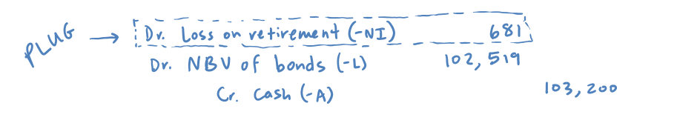

- Suppose Apple provides the following additional disclosure regarding some of the notes included in the “Fixed-rate 2.400% – 3.850% notes due 2023–2043” issued in 2013:

(in millions) | 2018 | 2017
$5,000 U.S. dollar 3.85% coupon notes due 2043 | $4,952.69 | $4,951.58

- (4 points) What is your best estimate of the interest expense that Apple recognized in fiscal year 2018 for these notes? Assume that Apple did not retire or issue additional notes in this category in 2018.

193.61 million, from the T-account below.
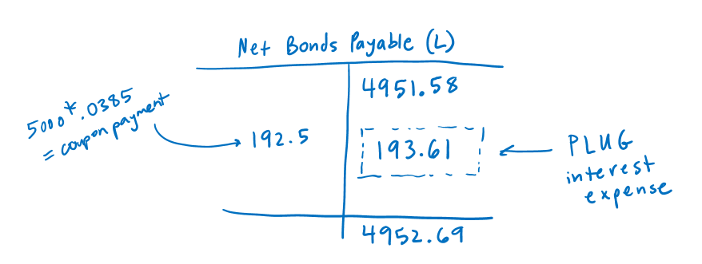

- (3 points) What is your best estimate of the historical “effective” interest rate that Apple uses to compute interest expense for these “U.S. dollar 3.85% coupon notes due 2043”?

Effective interest rate = Interest expense / beginning NBV

= 193.61 / 4951.58 = 3.91%

- (3 points) Without performing any time-value-of-money calculations, give your best estimate of the present value as of the end of fiscal year 2018 of all remaining coupon and principal payments related to these “U.S. dollar 3.85% coupon notes due 2043,” where the discount rate in the present value calculation is the historical effective interest rate that you estimated in part (b) above?

$4952.69, the net book value of the bonds at the end of 2018. Under the effective interest rate method, the net book value at any point in time is equal to the present value of all future bond payments, where the present value is calculated using the historical rate as the discount rate.

- Suppose that Apple has no intention to retire these “U.S. dollar 3.85% coupon notes due 2043” before they mature at the end of fiscal year 2043.

- (4 points) What is your best estimate of the net book value of the “U.S. dollar 3.85% coupon notes due 2043” as of the end of fiscal year 2019 (the year following the provided financial statements)?

$4953.84, from the ending balance of the T-account below.
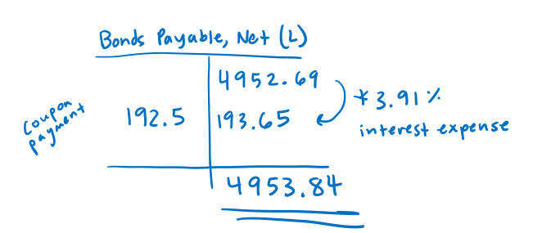

- (4 points) What is your best estimate of the cumulative amount of interest expense that Apple will recognize for these “U.S. dollar 3.85% coupon notes due 2043” between October 1, 2018 and September 30, 2043? Note that this period covers 25 annual coupon payments and the notes mature on September 30, 2043.

$4859.81, from the T-account below.